English 3 Letters Words

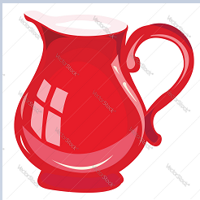 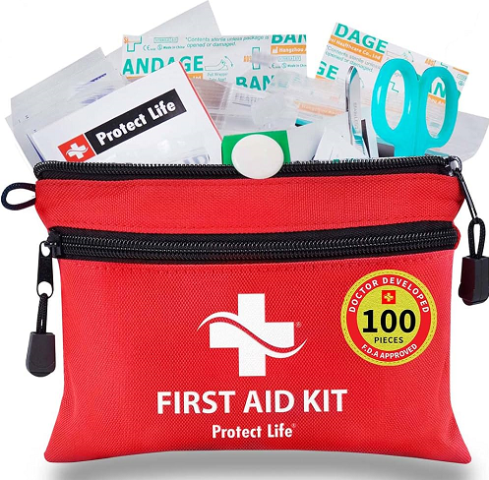

JUG KIT

SUN RAT

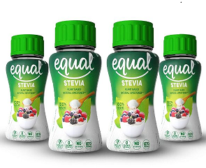 MAN 